**Instructions for CLEF 2017 Working Notes in the CEUR-WS Proceedings**

As in 2014, 2015 and 2016, The CLEF 2017 Labs working notes will be published in the [CEUR-WS.org proceedings](http://ceur-ws.org/index.html) (http://ceur-ws.org/index.html). The electronic Working Notes will be organised according to the Labs. If one group participates in more than one Lab, separate reports are to be submitted. Moreover, for those Labs that are subdivided in several tasks, separate reports for different task(s) are to be provided.

The publications will be divided into the following main sections (and sub-sections):

* CLEF NewsREEL
  + Task 1: NewsREEL Live
  + Task 2: NewsREEL Replay
* LifeCLEF
  + Task 1: PlantCLEF
  + Task 2: BirdCLEF
  + Task 3: SeaCLEF
  + Task 4: HabitatCLEF
* PAN Lab - Uncovering Plagiarism, Authorship and Social Software Misuse
  + Task 1: Author identification
  + Task 2: Author profiling
  + Task 3: Author obfuscation
* CLEF eHealth
  + Task 1: Multilingual Information Extraction
  + Task 2: Technologically Assisted Reviews in Empirical Medicine
  + Task 3: Patient-centred Information Retrieval
* CLEF Cultural Microblog Contextualization (CMC)
  + Task 1: Content Analysis
  + Task 2: MicroBlog Search
* ImageCLEF
  + Task 1: ImageCLEFcaption
  + Task 2: ImageCLEFtuberculosis
  + Task 3: ImageCLEFremote
* PIR-CLEF
* Early risk prediction on the Internet
* Dynamic Search for Complex Tasks
* Multimodal Spatial Role Labeling

When the author logs into easychair they will find a separate "Easychair Track" for each CLEF Lab/Workshop and once they have selected the correct "Easychair Track" for their, as in the figure below.

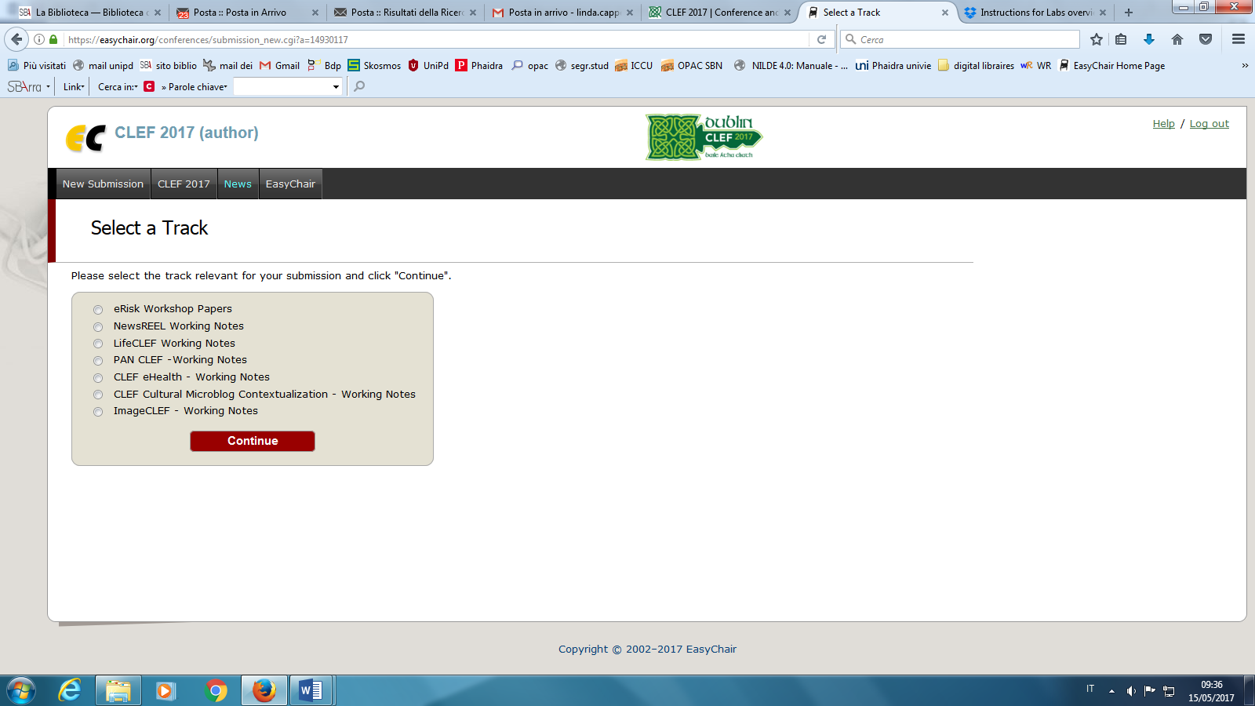

-> **Select** the track corresponding to your Lab/Workshop

Afterwards, in the paper upload form, after the keywords, authors will find a checklist with the "Submission Topics" corresponding to the different tasks in that Lab. Please mark one of them:

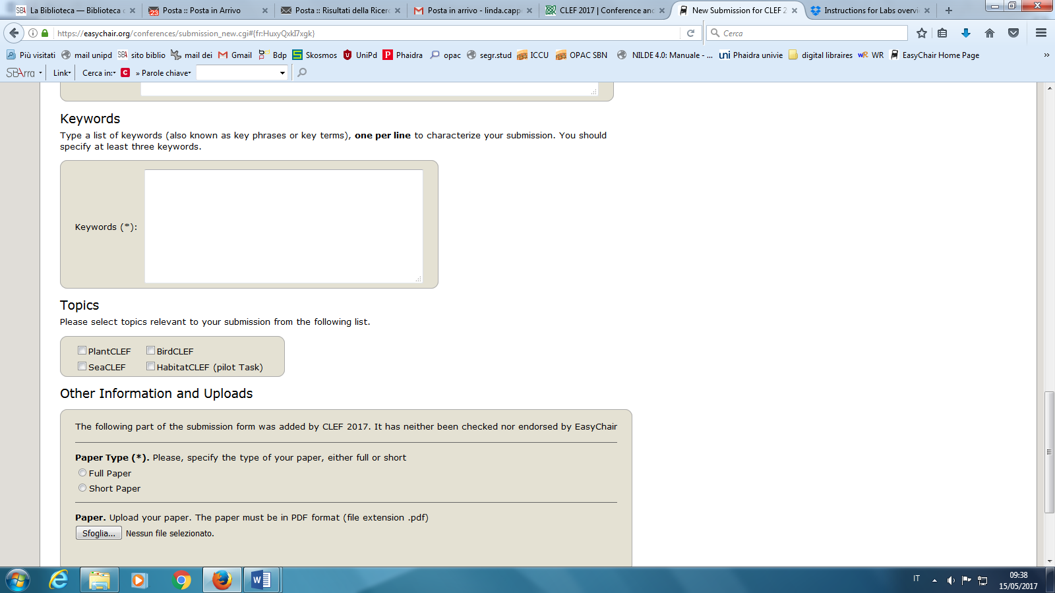

-> **Mark** the topic corresponding to your task

For each of the tasks in which they participated, groups are requested to submit a report describing their experiments. After the review process, if the paper will have been accepted, authors will be requested to submit the Camera-Ready Version of the paper, according to the reviewers' recommendations.

For each Camera-ready paper’s submission, three items are required:

* Zip file containing **all the submission sources**
* PDF file of the submission (**with no page headers/footers/page numbers**)
* PDF file with the scanned and signed copyright agreement (**otherwise, the submission will not be published in the final working notes**).

**Paper Submission**

Submission of papers is to be done electronically through the [Easychair system](https://easychair.org/conferences/?conf=clef2017) (https://easychair.org/conferences/?conf=clef2017).

Using EasyChair for Paper Submission

1. Authors must log in using their own username and password. If you don't already have an Easychair account, you will find the instructions to obtain one on the same page.
2. Once you have logged in, click on "New Submission", select the correct Lab/Track and Group/Task and then follow the instructions to submit your paper.

**Please, note that for final Working Notes we'll use the metadata of Easychair submission, so pay attention to insert authors names, title and affiliations correctly.**

**Deadlines**

Please remember that the strict deadline for receiving the final electronic versions of all papers is:

1. Working Notes Papers due **May 26, 2017, 11:59 pm - midnight - Central European Summer Time**. This is a STRICT DEADLINE.
2. CEUR-WS Camera Ready Working Notes Papers due **July 3, 2017, 11:59 pm - midnight - Central European Summer Time**. This is a STRICT DEADLINE

**Copyright Form**

During the upload of the Camera-Ready version of the accepted papers, a scanned and signed version of the [CLEF copyright form](http://clef2017.clef-initiative.eu/resources/CLEF2017-WorkingNotes-CopyrightForm.txt) (http://clef2017.clef-initiative.eu/resources/CLEF2017-WorkingNotes-CopyrightForm.txt) must be uploaded with the source and PDF files of the submission (otherwise the submission will not be published in the final working notes).

**GUIDELINES TO PREPARE REPORTS FOR CLEF2017 WORKING NOTES**

The working notes papers are technical reports written in English and describing the participating systems and the conducted experiments. They should provide, at least, the following information:

1. Title
2. Authors
3. Affiliations
4. Email addresses of all authors
5. Body of text. This should contain information on:
   * tasks performed
   * main objectives of experiments
   * approach(es) used and progress beyond state-of-the-art
   * resources employed
   * results obtained
   * analysis of the results
   * perspectives for future work

The papers must be formatted according to Springer Instructions for Authors, whose Word and Latex templates are available at:  
    <http://www.springer.com/computer/lncs?SGWID=0-164-6-793341-0>

MAX LENGTH: no upper page limit is set, as papers are published only electronically.